**Module 7 Problem 4**

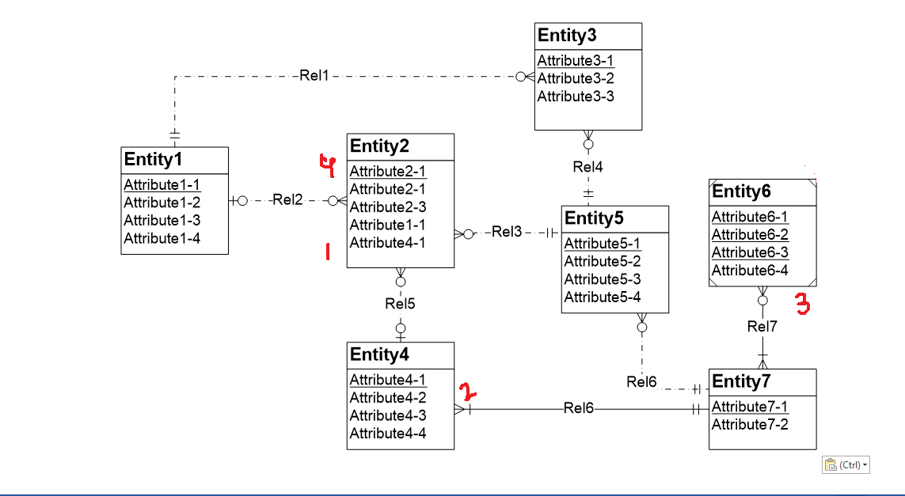

Violation Indication – (Indicated in red and having it’s serial no)

Violation 1) Foreign Key rule Violation.

Violation 2) Identifying relationship Rule Violation.

Violation 3) Identification Dependency Cardinality Rule Violation.

Violation 4) Attribute Name Rule Violation.

**Solutions**

Solution 1) Remove attributes 1_1 and 4_1.

Solution 2) Use dashed line instead of strong line.

Solution 3) Change cardinality of Entity 7 from ‘Many Mandatory’ (crow foot) to ‘One Optional’ (2 perpendicular lines) .

Solution 4) Rename one of the attributes from Entity2 named Attribute2_1 to something such that it should not match with any attribute in Entity2.